NAR Registry User Guide
The North American Renewables Registry (NAR) Application provides an easy-to-use, Web-based platform, trusted to create, track, and manage renewable energy certificate (REC) origination for clean generation facilities and areas not covered by one of the existing APX-powered, regional systems.

This User Guide outlines the steps for how to register new renewable energy generators and aggregated projects, upload generation data, issue RECs, and initiate REC transfers.

A. NAR Account Types

The different NAR Account Types are listed below. Access to NAR is controlled by a User Role. The different User Roles and their access rights are also shown below:

Account Type | Register Assets | Issue RECs | Hold RECs | Receive RECs | Transfer RECs | Retire RECs | Upload Generation Data | View and approve Accounts and Assets
General Account | Yes | Yes | Yes | Yes | Yes | Yes | Yes | No
Project Account | Yes | Yes | Yes | No | Yes | Yes | Yes | No
Retail Purchaser Account | Yes | Yes | Yes | Yes | No | Yes | No | No
Qualified Reporting Entity (QRE) | No | No | No | No | No | No | Yes | No
Program Administrator | No | No | No | No | No | No | No | No
NAR Administrator Account | Yes | Yes | Yes | Yes | Yes | Yes | Yes | Yes

B. Register Asset – Renewable Energy Generator and Aggregated Project

The Asset Management module is used to register and manage NAR Assets. Before registering a new Asset, make sure the Asset you are registering does not already appear on the list of previously registered Assets.

Renewable Energy Generator
- To register a new Renewable Energy Generator Asset, go to the Asset Management module and click the ‘Register New Asset’ hyperlink as shown below:
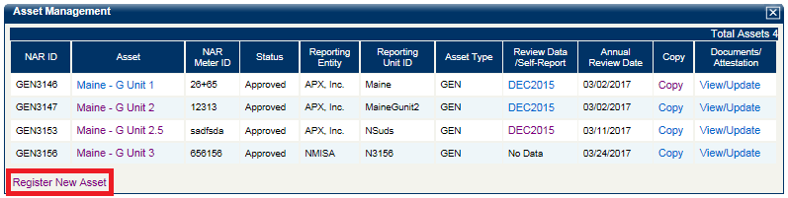

- In the New Asset Registration screen, select the Renewable Energy Generator Asset Type and enter data into all fields denoted with an asterisk. Once complete, click the ‘Next’ button to continue with the asset registration.

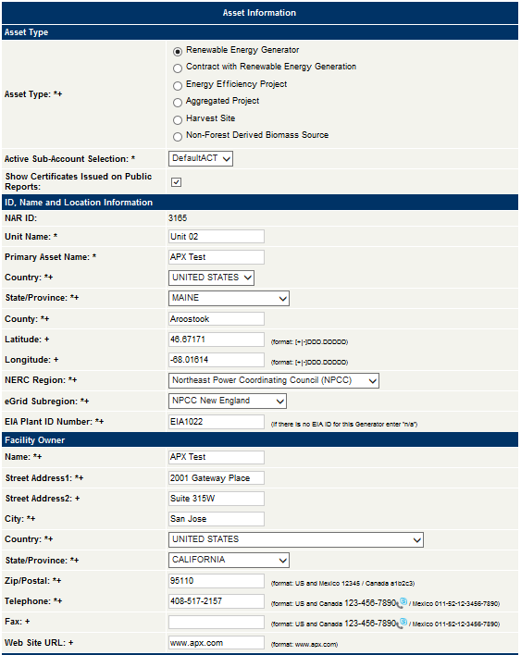
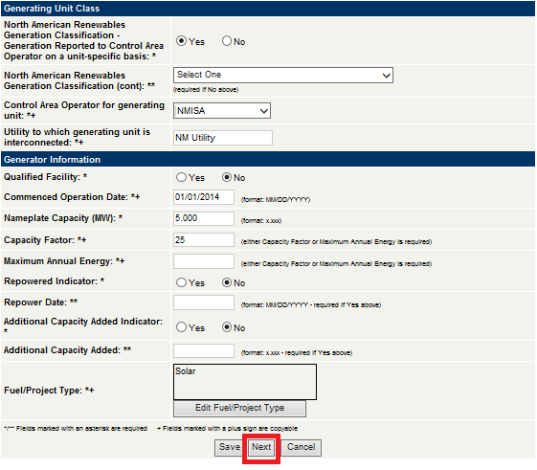

- In the Generator/Project Registration screen, enter data into all fields denoted with an asterisk and click the ‘Next’ button to continue with the asset registration.
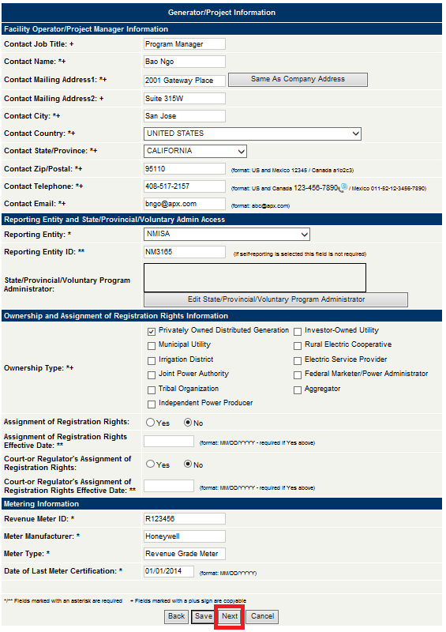
Note: Under the Reporting Entity and State/Provincial/Voluntary Admin Access section, User must assign the Reporting Entity that is responsible for reporting generation data for the asset.

- In the Generator/Project Information screen, select the ‘Yes’ Radio Button for the REC State/Provincial/Voluntary Eligibilities that apply for the asset.

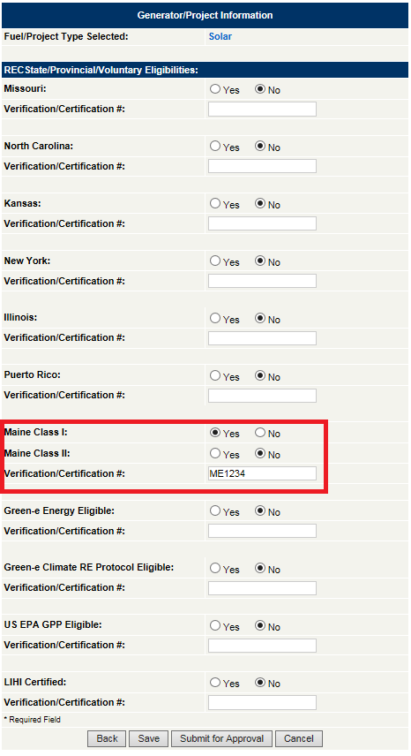
- Once all the required data has been entered in Asset Registration, click the ‘Submit for Approval’ button to create the new Asset.

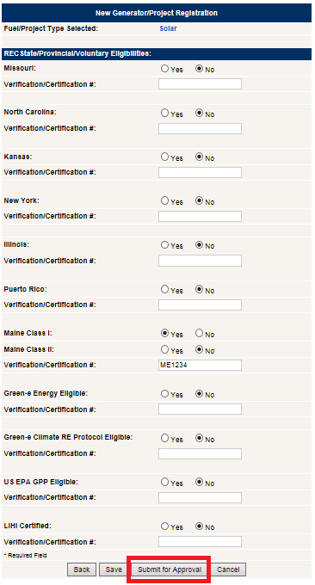

- After User clicks the ‘Submit for Approval’ button,a confirmation message appears to inform the User that the Asset has been created and is pending approval by the NAR Administrator.

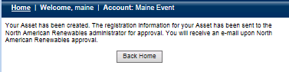

Note: At any time during this process, the User can click the ‘Save’ button and return to the Asset to complete the registration at a later time. The User should only click the ‘Submit for Approval’ button when all the necessary information is entered and is ready for Asset to be created.

Aggregated Project

- To register a new Aggregated Project, go to the Asset Management module in NAR and click the ‘Register New Asset’ hyperlink as shown below:

- In the New Asset Registration screen, select the Aggregated Project Asset Type and enter data into all fields denoted with an asterisk. Once complete, click the ‘Next’ button to continue with the asset registration.
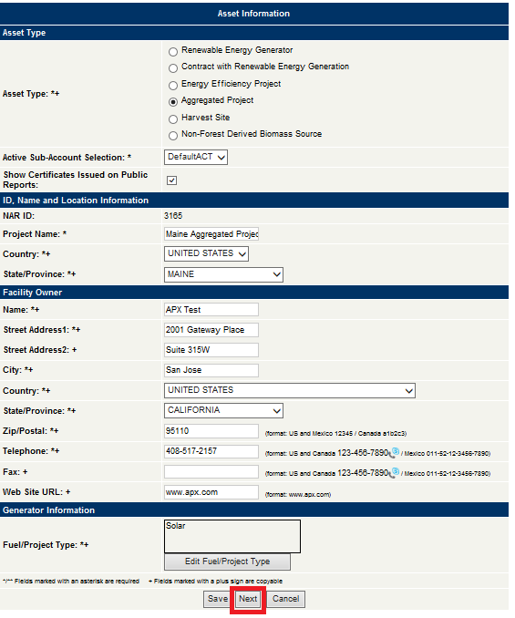

- In the Generator/Project Information screen, User has two options to add aggregated units: Manual or Batch Upload.

  - Manually add aggregated units
    - Click the ‘Add’ button and enter all the fields on the table to add the Aggregated Unit.
    - Repeat this step until all aggregated units are added.
    - Once complete, click the ‘Next’ button to continue with the asset registration.

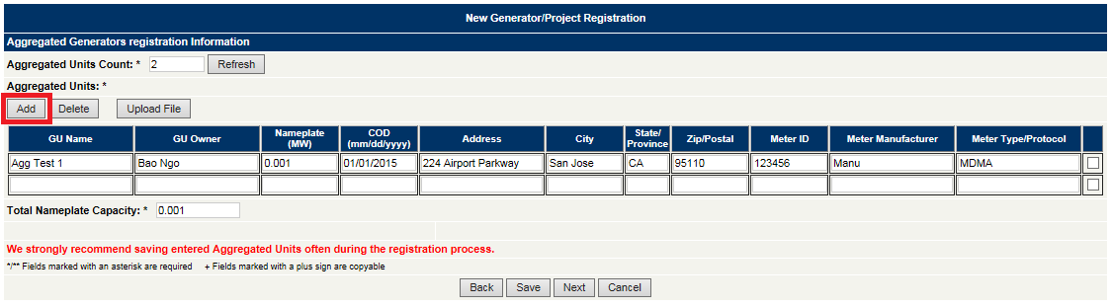

  - Batch upload aggregated units
    - Create a CSV file and enter all the fields for each aggregated unit. Below are the fields that are required for the CSV file:
      - Unit Name
      - Unit Owner
      - Nameplate Capacity (MW)
      - COD (mm/dd/yyyy)
      - Address
      - City
      - State/Province
      - Zip Code/Postal Code
      - Meter ID
      - Meter Manufacturer
      - Meter Type/Protocol
    - In the Generator/Project Information screen, click the ‘Upload File’ button.
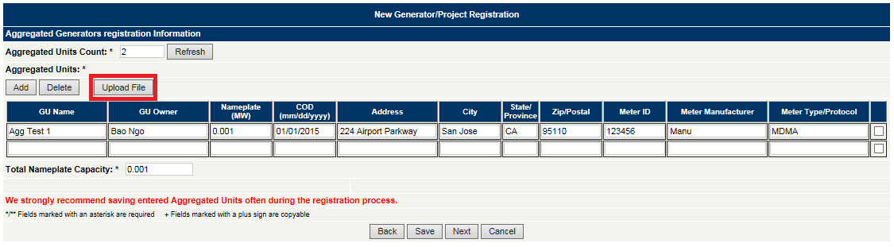

    - In the Upload Aggregated Generators screen, click the ‘Browse’ button to locate and select the upload file.

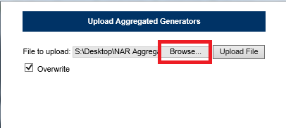

    - Click the ‘Upload File’ button to upload aggregated units to the Generator/Project Information screen.

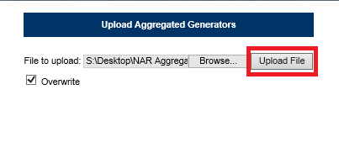

    - Review the aggregated units uploaded to the Generator/Project Information screen.
    - Once complete, click the ‘Next’ button to continue with the asset registration.

Note: If the ‘Overwrite’ checkbox is selected, the Batch upload file will overwrite any existing data that was previously loaded.

- In the Generator/Project Registration screen, enter data into all fields denoted with an asterisk and click the ‘Next’ button to continue with the asset registration.

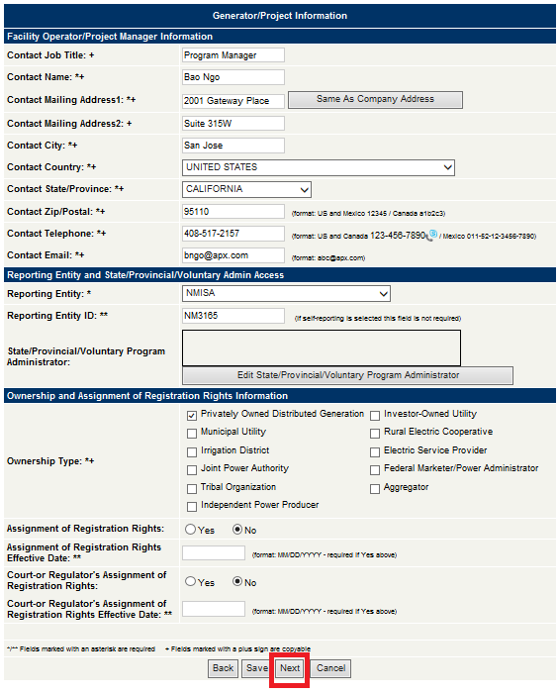

Note: Under the Reporting Entity and State/Provincial/Voluntary Admin Access section, User must assign the Reporting Entity that is responsible for reporting generation data for the asset.

- In the Generator/Project Information screen, select the ‘Yes’ Radio Button for the REC State/Provincial/Voluntary Eligibilities that apply for the asset.

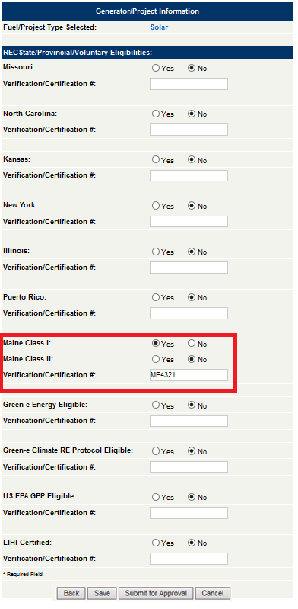
- Once all the required data has been entered in Asset Registration, click the ‘Submit for Approval’ button to create the new Asset.

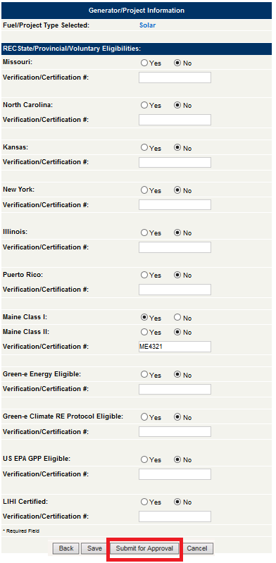

- After User clicks the ‘Submit for Approval’ button,a confirmation message appears to inform the User that the Asset has been created and is pending approval by the NAR Administrator.

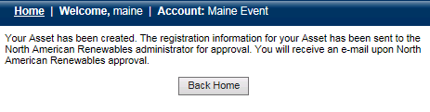

Note: At any time during this process, the User can click the ‘Save’ button and return to the Asset to complete the registration at a later time. The User should only click the ‘Submit for Approval’ button when all the necessary information is entered and is ready for Asset to be created.

C. Generation Data Loading

The Reporting Entity of the Asset reports generation data to NAR. There are two ways to report data into the Registry: Manual Generation Data Loading by Asset or via Batch Upload for multiple Assets simultaenously.

Generation Data Manual Loading:

- Go to the Meter Data Loading module and click the ‘Asset’ hyperlink under the Asset column as shown below.
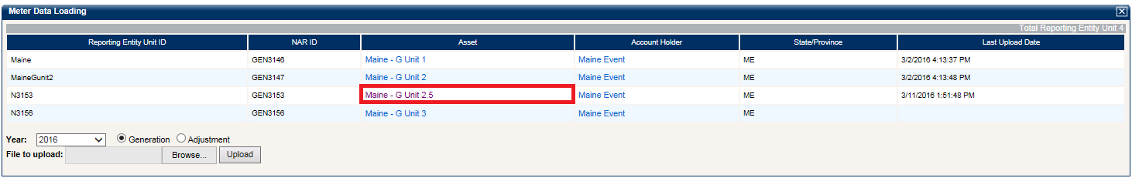
- In the Self-Reporting/Facility/Project Output Data Review screen, click the ‘Add New Output’ button.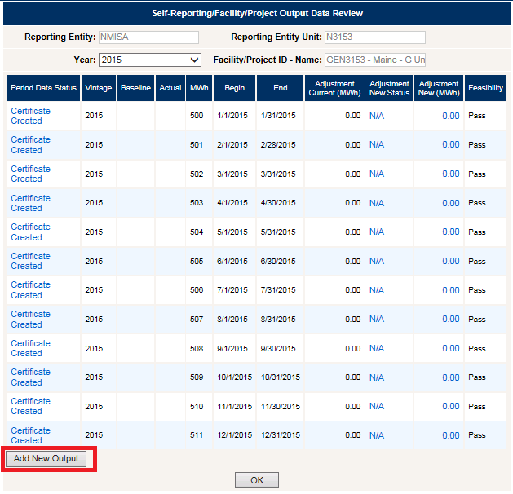

- In the Self-Reporting/Facility/Project Output Data Accept-Dispute screen, enter data for the required fields.

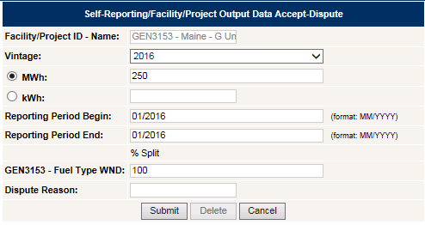

- Click the ‘Submit’ button.

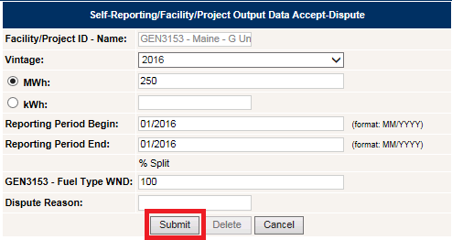

- After clicking the ‘Submit’ button, a pop-up box will appear to confirm action. Click the ‘OK’ button to load the generation data for the asset.

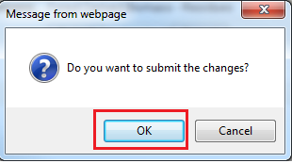
Note: Generation data that is loaded and that passes the feasibility validation will automatically be placed in “NAR Accepted” status for review. Before RECs are issued, the Reporting Entity can either resubmit or delete Generation data.

Generation Data Batch Upload:

- Create a CSV file for Generation Data Batch Upload. The fields in the Generation Data Batch Upload CSV file must contain:
  - NAR ID
  - Reporting Entity Unit ID
  - Vintage
  - Start Date
  - End Date
  - Total MWh

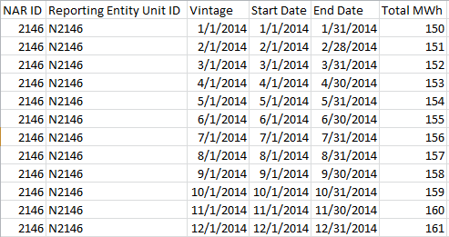

- Go to the Meter Data Loading module in NAR, under the ‘Year’ drop-down, select the year, select either the ‘Generation’ or ‘Adjustment’ Radio Button, and click the ‘Browse’ button to locate the file.

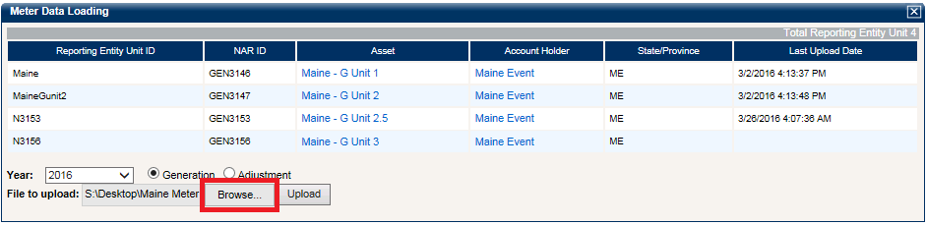

- Click the ‘Upload’ button to upload the Generation Data Batch Upload file.

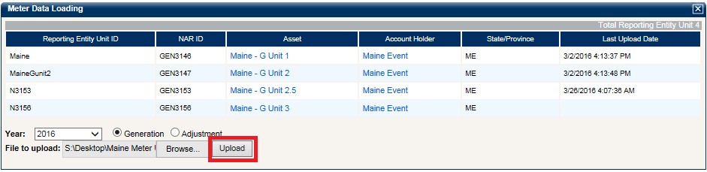

- After clicking the ‘Upload’ button, a confirmation screen will appear to display and confirm the results of the upload.

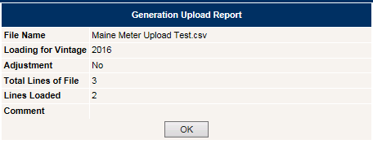
Note: If there are any issues with the upload, an error message will appear in the Comment section and the file will not be uploaded.
D. REC Issuance

Once generation data is uploaded, NAR will notify the User via email that the data has been posted. The User can log in to review the uploaded generation data and ‘Accept’ or ‘Dispute’ generation data.

- Go to the Asset Management module, click the ‘Year’ hyperlink under the Review Data/Self Report column as shown below.
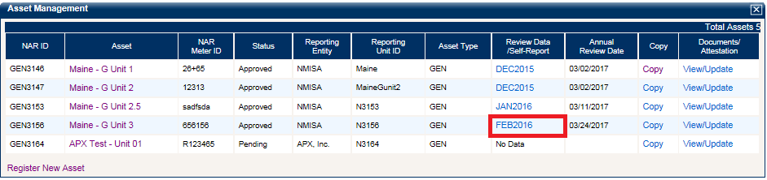
- In the Self-Reporting/Facility/Project Output Data review screen, click the ‘NAR Accepted” hyperlink under the Period Data Status column.
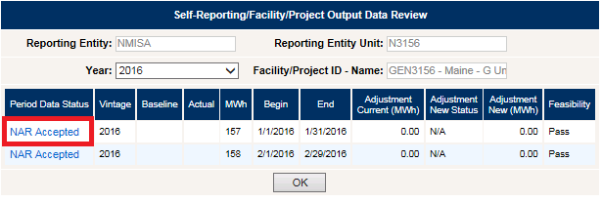

- Click the ‘Accept’ button to issue RECs immediately.
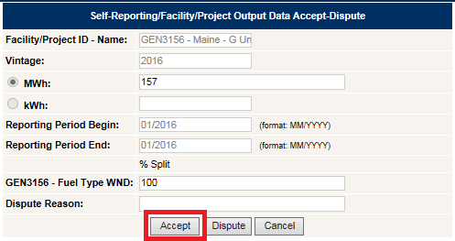

- If there are any issues with the generation data, click the ‘Dispute’ button. An email will be sent to the Reporting Entity and NAR Administrator to review and resolve the dispute.

Note: If the User does not ‘Accept’ or ‘Dispute’ the reported generation data, all generation data in ‘NAR Accepted’ status will result in REC issuance 14 days after the data was reported by the Reporting Entity.

E. Renewable Energy REC Transfers

Once RECs are issued, active RECs will be available in the User’s Active Sub-Account in NAR. There are three transfer options that are applicable to Singapore RECs:
- Another Account Holder
- Active
- Retirement
- Export
- Bulletin Board

To transfer RECs, the User uses the Transfer Credit screen to initiate a transfer of RECs from an Active Sub-Account to a transfer option available on the Transfer screen.

Initiate REC Transfers to Another Account Holder:

- Go to the Account Status module in NAR and click the hyperlinked REC quantity in the ‘Active’ row as shown below:
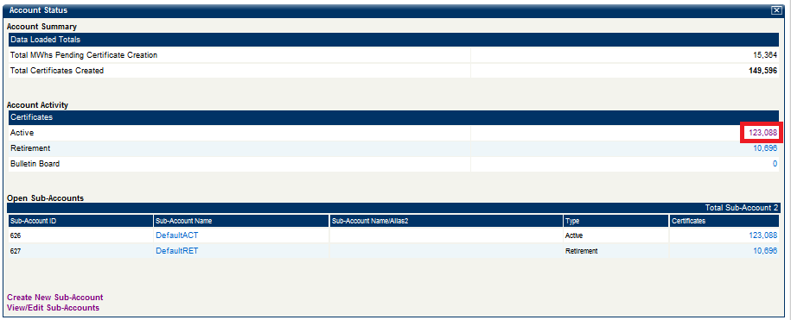

- Select one or more blocks of RECs for transfer and click the ‘Batch Transfer’ button.
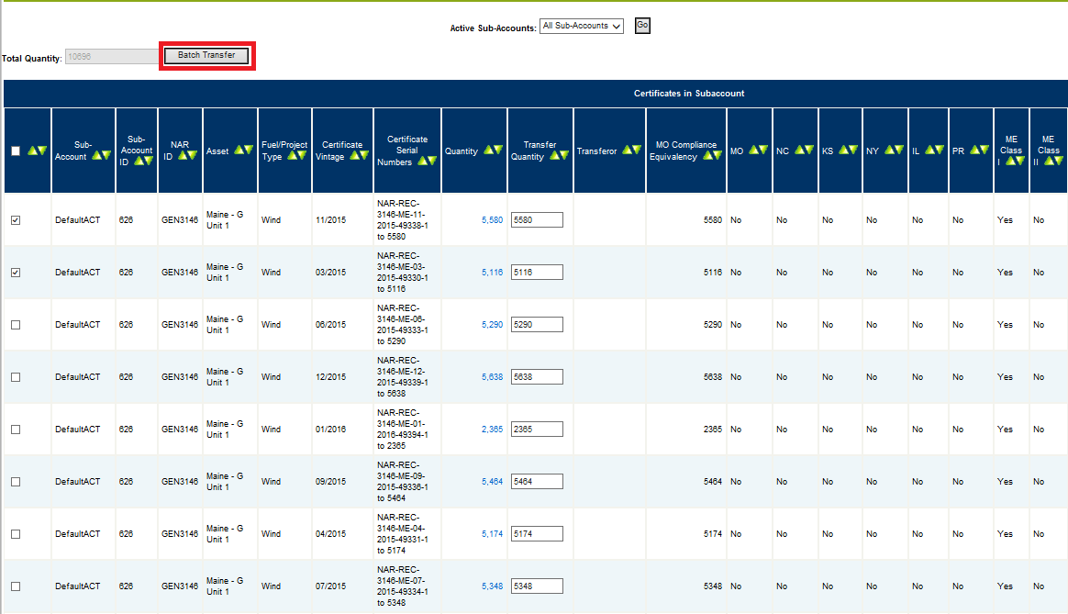
- Select the ‘Another Account Holder’ radio button transfer option, select the Account Holder from the drop down, and click the ‘Submit’ button to initiate transfer.
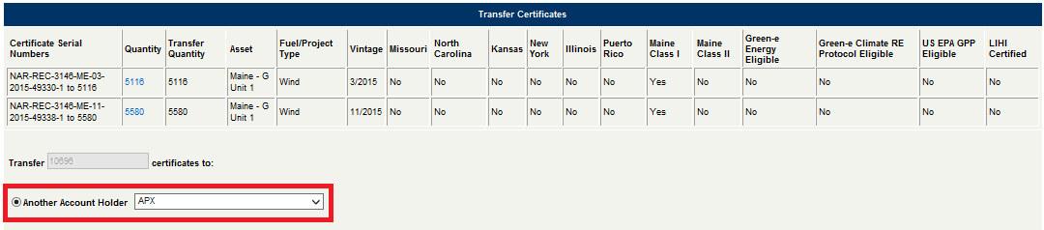

- After clicking the ‘Submit’ button, a pop-up box will appear to confirm action. To execute the transfer, click the ‘OK’ button to transfer the RECs to the designated transfer option.
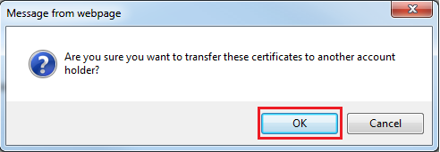

Note: After initiating a REC transfer to another Account Holder, the transferred RECs are marked as “Pending” in the Transferor’s Outbox until the Transferee either accepts or rejects the transfer. If rejected, the RECs will be returned to the Active Sub-account from which they were transferred.

Transfer RECs to an Active Sub-Account:

- Go to the Account Status module in NAR and click the hyperlinked REC quantity in the ‘Active’ row as shown below:
- Select one or more blocks of RECs for transfer and click the ‘Batch Transfer’ button.
- Select the ‘Active’ radio button transfer option, select the Active Sub-Account from the drop down, and click the ‘Submit’ button to initiate transfer.
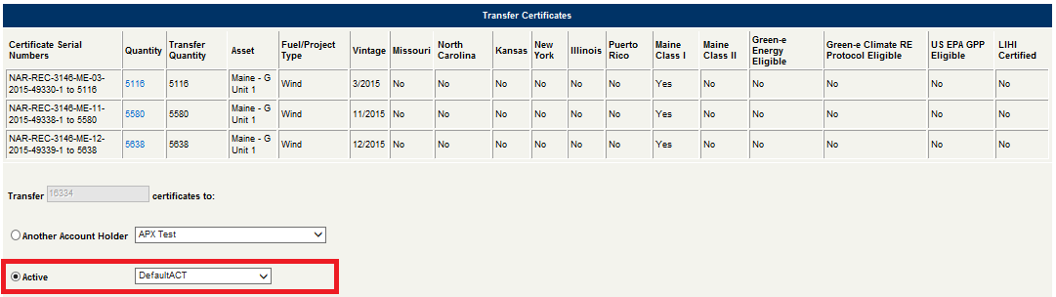

- After clicking the ‘Submit’ button, a pop-up box will appear to confirm action. To execute the transfer, click the ‘OK’ button to transfer the RECs to the designated Active Sub-Account.

Transfer RECs to a Retirement Sub-Account:

- Go to the Account Status module in NAR and click the hyperlinked REC quantity in the ‘Active’ row as shown below:

- Select one or more blocks of RECs for transfer and click the ‘Batch Transfer’ button.

- Select the ‘Retirement’ radio button transfer option, select the Retirement Sub-Account from the drop down, check the Retirement Type, provide the Retirement Details, and click the ‘Submit’ button.
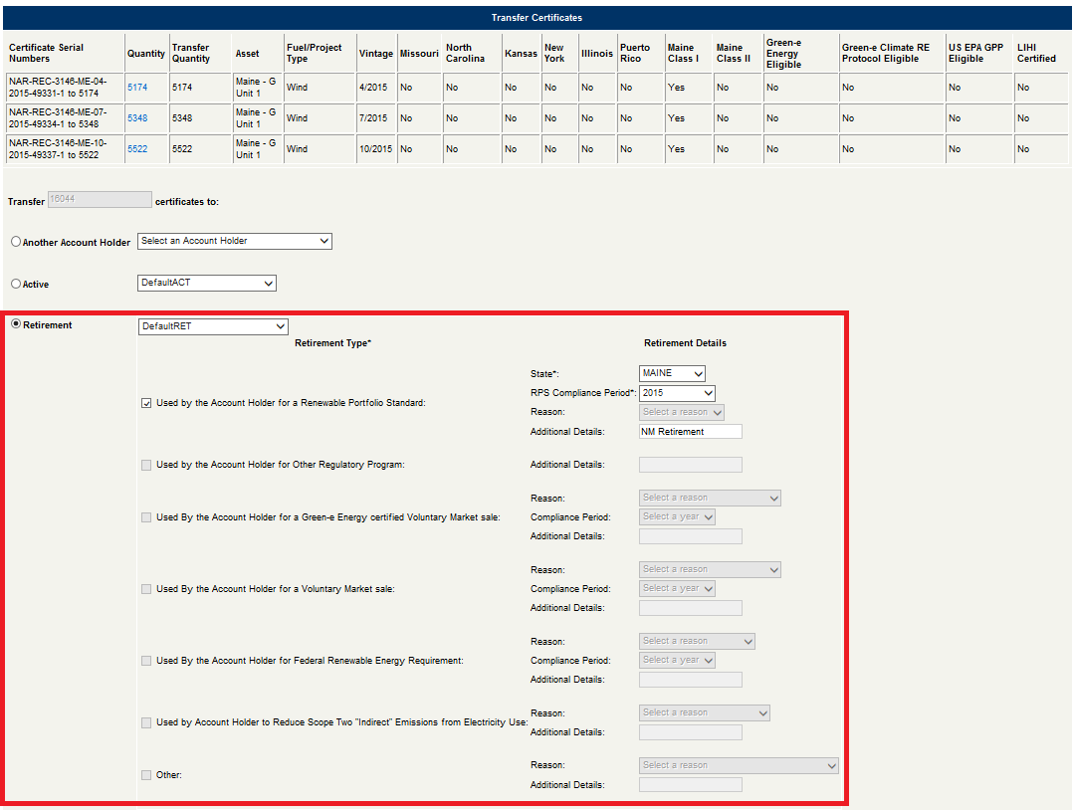
- After clicking the ‘Submit’ button, a pop-up box will appear to confirm action. To execute the transfer, click the ‘OK’ button to transfer the RECs to the designated Retirement Sub-Account.

Note: Retired RECs cannot be moved or transferred out of the Retirement Sub-account to any other Account or Account Holder.
Export RECs to a Compatible Tracking System:

- Go to the Account Status module in NAR and click the hyperlinked REC quantity in the ‘Active’ row as shown below:
- Select one or more blocks of RECs for transfer and click the ‘Batch Transfer’ button.

- Select the ‘Export’ radio button transfer option, select the Compatible Tracking System from the drop down, enter Account ID and Account Name, and click the ‘Submit’ button to initiate transfer. 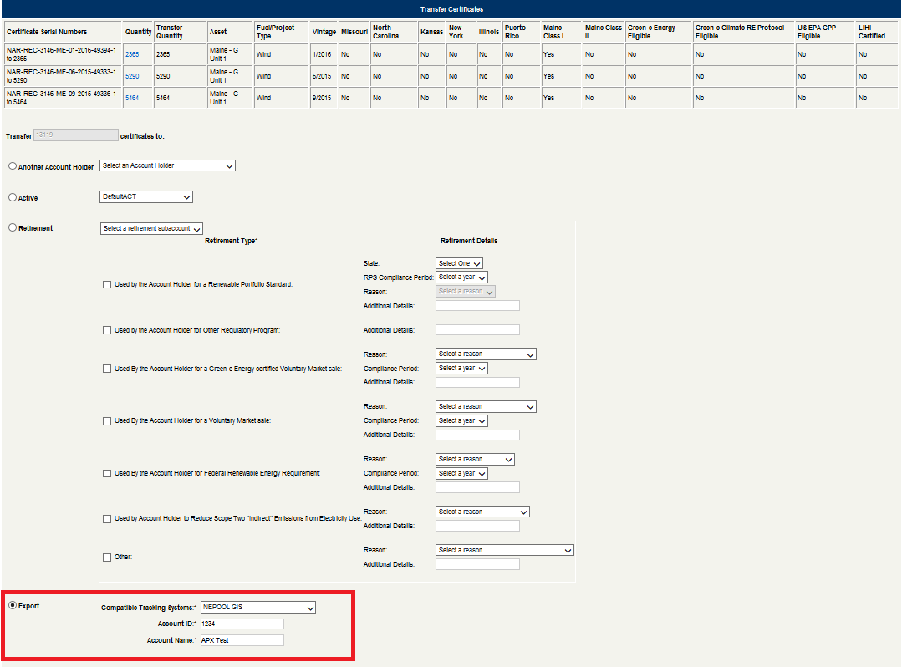
- After clicking the ‘Submit’ button, a pop-up box will appear to confirm action. To execute the transfer, click the ‘OK’ button to transfer the exported RECs to the Compatible Tracking System.
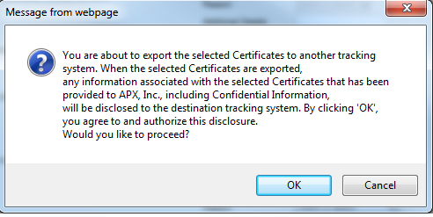
Note: Exported RECs cannot be retired in a Retirement Sub-account for any purpose in NAR.

Transfer RECs to the NAR Bulletin Board:

- Go to the Account Status module in NAR and click the hyperlinked REC quantity in the ‘Active’ row as shown below:
- Select one or more blocks of RECs for transfer and click the ‘Batch Transfer’ button.

- Select the ‘Bulletin Board’ radio button transfer option and click the ‘Submit’ button to initiate transfer.
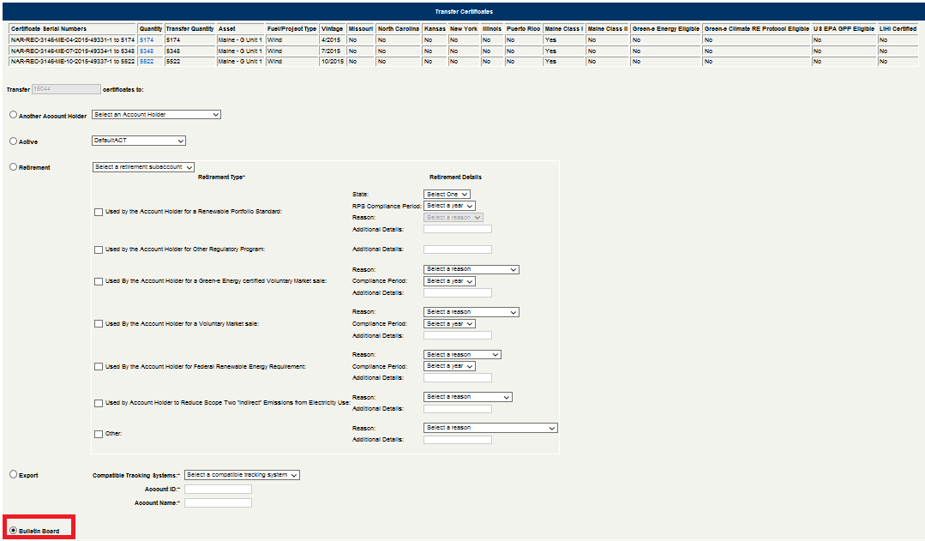
- After clicking the ‘Submit’ button, a pop-up box will appear to confirm action. To execute the transfer, click the ‘OK’ button to transfer the exported RECs to the Compatible Tracking System.

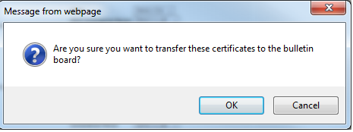
Note: RECs transferred to the Bulletin Board will be displayed on the Bulletin Board report under the
Public Reports module in NAR.

F. Accept/Reject/Withdraw Pending REC Transfers

After a REC transfer is initiated, the system sends an electronic notification to both the Transferor and the Transferee. During this time, RECs are placed in a ‘Pending’ status and cannot be moved to another Sub-account or to another Account Holder. However, the Transferor can withdraw the transferred RECs and the Transferee can accept or reject the pending transferred RECs.

Withdraw REC Transfers in Transferor’s Account:

- Go to the Outbox module in NAR and check a batch and click the ‘Withdraw’ hyperlink for a specific REC transfer or check the checkboxes for multiple batches and click the ‘Withdraw Selected’ hyperlink.

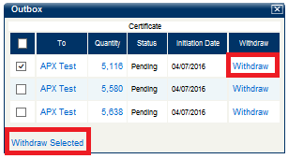
- A pop-up box will appear to confirm action. To Withdraw the pending transfer, click the ‘OK’ button.

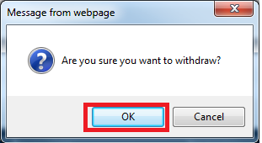

Accept REC Transfers in Transferee’s Account:

- Go to the Inbox module in NAR and check the specific batch and click the ‘Accept’ hyperlink for a specific REC transfer or check the checkboxes for multiple batches and click the ‘Accept Selected’ hyperlink.
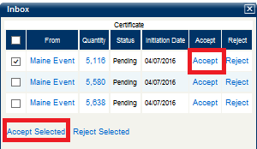
- In the Certificate Transfer Confirmation page, User selects the Active Sub-Account where the RECs should be deposited and click the ‘Accept’ button.
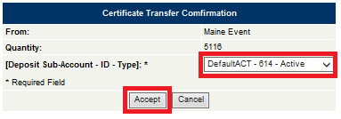

Reject REC Transfers in Transferee’s Account:

- Go to the Inbox module in NAR and check the batch and click the “Reject” hyperlink for a specific REC transfer or check the checkboxes for multiple batches and click the “Reject Selected” hyperlink.
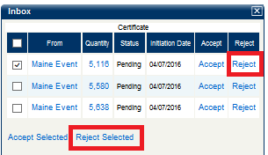
- A pop-up box will appear to confirm action. To Reject the pending transfer and transfer the RECs back to the Transferor, click the ‘OK’ button.

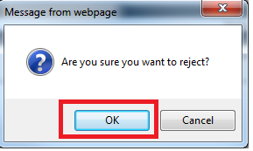

G. Reports

In NAR, Users can access specific reports accessible to only the User, their designated Agents, Regulators, and the NAR Administrator. Go to the Account Holder Reports module in NAR and click the hyperlinked Report links to view up-to-date data in these reports at any time.

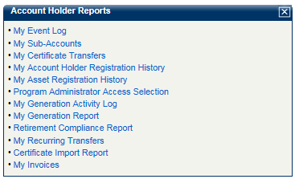

General Account is the only type of account that can retire on behalf of an Indirect Owner and for any Compliance Program using NAR.
Retail Purchaser Account can register and maintain projects that are under 1MW in capacity.

